Philadelphia 76ers Team, Player, and Salary Evaluation

2022-23 Season

Kevin O’Donnell, Tim Noel, Tim Brown

1. **Introduction and Data Collection**

As consultants for the Philadelphia 76ers, we evaluated this past regular season (2022-23) with respect to chosen KPIs and the rest of the NBA. We collected season-aggregated data from the 2012-2013 season through the 2021-22 season to establish team and player KPIs and train a model to predict players’ salaries based on their performance. We collected identical data for the 2022-23 season to evaluate the Philadelphia 76ers this year based on these metrics and the model.

Our full set of team and player data included a variety of basic and advanced statistics to measure offensive and defensive performance for players and teams. The data were all measured on a per 48-minute basis to adjust for each player’s time on the court. We also scraped yearly salary data from hoopshype.com for our player value analysis.

1. **Establishing Team KPIs**

To establish team KPIs from our large set of season statistics, we elected to loop through all numeric variables and calculate their correlations to winning percentage. We did this to determine which statistics are most closely related to winning. We also adopted Dean Oliver’s Four Factor approach to basketball. Dean Oliver is a renowned basketball statistician who introduced the “four factors of basketball success” in his book *Basketball on Paper.* These four factors are the general aspects of the game he determined to be most influential for winning. He applied the following weights to these factors:

* Shooting (40%)
* Turnovers (25%)
* Rebounding (20%)
* Free Throws (15%)

Using the calculated correlations with winning percentage, we took the most strongly correlated variables from each factor and chose them. For example, turnovers can be recorded as a counted statistic or as a percentage. Turnover percentage is the number of turnovers a team commits per 100 possessions. Turnovers had a correlation of –0.252 with winning percentage, while turnover percentage had a correlation of just –0.235. Since the absolute value of this correlation was lower, we elected to focus on turnovers per 48 minutes to evaluate how well Philadelphia took care of the ball this year.

**Exhibit 1:**

|  |  |
| --- | --- |
| Variable | Correlation with Win % |
| TOV | -0.25209 |
| TOV % | -0.23492 |

We applied this same logic to each factor which resulted in choosing the following KPIs to focus on:

* Effective Field Goal Percentage (EFG%)
* Turnovers (TOV)
* Total Rebounding Percentage (TREB%)
* Free Throw Percentage (FT%)

Effective field goal percentage is a shooting efficiency metric that adjusts for the point values of three pointers versus two pointers, giving them 1.5 times the importance. The formula is this: (FGM + 0.5 * 3PM) / FGA. This statistic is more reflective of shooting performance relative to wins than standard field goal percentage, so it makes sense to focus on it.

**Exhibit 2:**

|  |  |
| --- | --- |
| Variable | Correlation with Win % |
| FG% | 0.64098 |
| TS% | 0.60671 |
| EFG% | 0.57658 |
| FG3% | 0.56974 |
| FG2% | 0.46578 |
| pts | 0.37962 |
| FGM | 0.35851 |
| FG3M | 0.23556 |
| FT% | 0.23536 |
| FG2A | -0.21012 |
| FTM | 0.19066 |
| FG3A | 0.13266 |
| FTA | 0.09897 |
| FG2M | 0.08628 |
| FGA | -0.05704 |

We will note that true shooting percentage had a slightly higher correlation than effective field goal percentage (0.607 compared to 0.577), but true shooting percentage includes free throws as well as two and three pointers. We chose EFG% to separate free throw shooting from shots in the run of play, since shooting and free throws are separate factors. Field goal percentage also had a higher correlation, but we chose to focus on effective field goal percentage because of the league’s growing affinity for the three-point shot. As shown in the chart below, the average three pointers attempted by NBA teams have steadily increased from 19.81 per 48 minutes in 2013 to 34.98 in 2022. As a result, we believe that effective field goal percentage will be more reflective of team success in years to come. In fact, if you only include the past three seasons, EFG% has a higher correlation with winning percentage than FG% (r=0.714 compared to r=0.665). Thus, we amended our approach slightly and chose EFG% over FG% because it is more comprehensive and aligns better with league trends.

**Exhibit 3:**

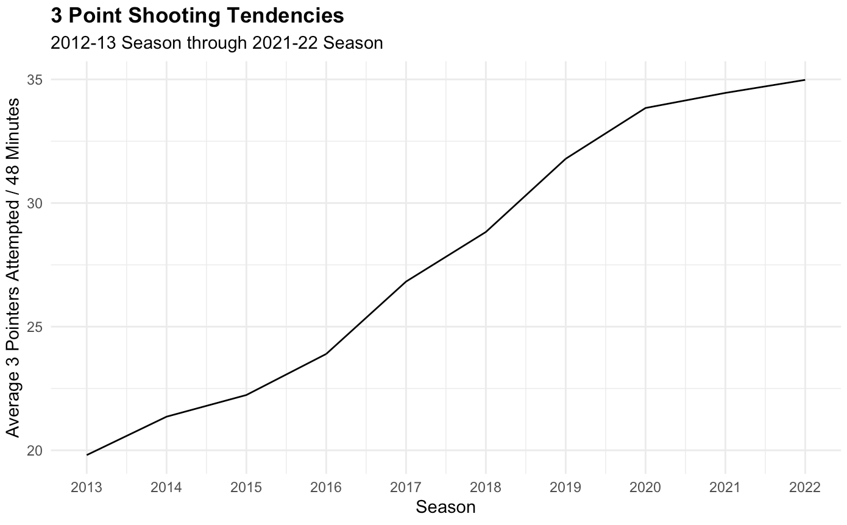

Total Rebounding Percentage is the percentage of available rebounds a team secures. It is calculated by dividing the total rebounds a team earns by the total number of rebounds in the game: REB / (REB + Opponent REB). This stat had the highest absolute correlation with winning percentage amongst all rebounding related metrics at 0.433. We prefer to use this statistic over raw rebounds for this reason and because it accounts for available rebounds. It is basically an efficiency statistic for rebounds.

**Exhibit 3:**

|  |  |
| --- | --- |
| Variable | Correlation with Win % |
| TREB% | 0.433 |
| DREB | 0.366 |
| TREB | 0.279 |
| DREB | 0.187 |
| OREB | -0.114 |
| OREB% | 0.009 |

Finally, we chose to key in on free throw percentage as our free throw metric. We chose this over the number of free throws made or attempted per 48 minutes because it had a higher correlation with winning percentage and because it incorporates both of those statistics.

**Exhibit 4:**

|  |  |
| --- | --- |
| Variable | Correlation with Win % |
| FT% | 0.23536 |
| FTM | 0.19066 |
| FTA | 0.09897 |

We advise the 76ers to examine these KPIs in order of importance from effective field goal percentage down to free throw percentage.

Additionally, using these KPIs, we created a “four factor score” to evaluate overall team performance. We first grouped the data by year and obtained the percentiles for each variable and team. This gave us a percentile “score” for each statistic. Using each score and its associated weight determined by Dean Oliver, we created the aggregate four factor score. This is the formula:

Four Factor Score (FFS) =

For the teams in the training set (2012-13 through 2021-22), FFS was strongly correlated with winning percentage (r=0.599). We believe this to be a strong overall measure of performance that the 76ers can track as the season progresses because of this strong relationship and its ability to incorporate important aspects of the game.

**Exhibit 5:**

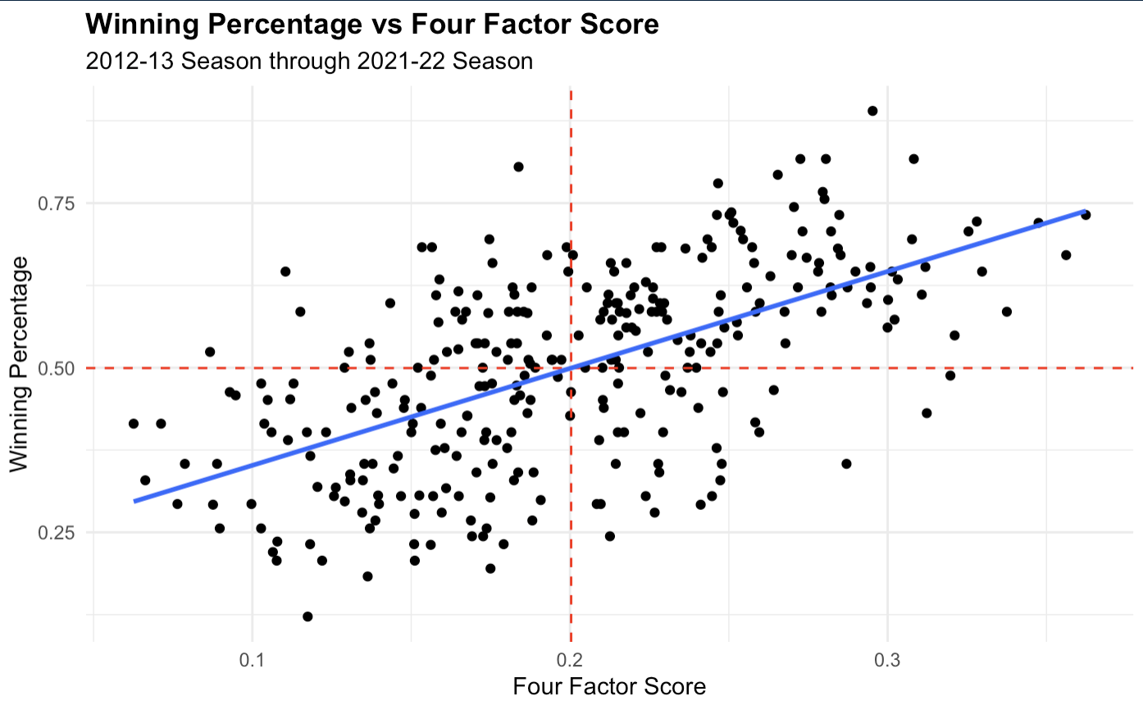

1. **Establishing Player KPIs**

For player KPIs, we elected to follow through with a four-factor approach but add defensive statistics to our consideration as well. Again, we used data from 2012-2022. We created an offensive score and a defensive score for each player and summed the two for an all-around “player score.” This player score should weigh offense and defense equally.

Offensive Score

To create the offensive score, we considered the four factors and chose the following statistics for each factor: points per 48 minutes, offensive rebounding percentage (OREB%), free throw percentage (FT%), and turnovers (TOV). We chose points instead of effective field goal percentage as a proxy for shooting because choosing EFG% gave unreasonably high scores to players who shot very few shots throughout the season. While points per 48 minutes still falls victim to some small sample sizes, it is less responsive to players with little playing time. We also chose offensive rebounding percentage, instead of total rebounding percentage as in the team section, because this should be an offensive measure only.

Our team computed the percentile value for each player for each statistic and then calculated the correlation of these normalized statistics with offensive box plus minus (OBPM) per position group. We grouped players into guards, forwards, and centers. We chose to use BPM as our reference for offense and defense because it aims to estimate a player’s overall contribution to their team and is decomposed into their offensive and defensive performance. It is measured in their contribution in points above league average.

We used the resulting correlations to determine weights for each normalized statistic in calculating the offensive player score. The weights are equal to the correlation of each variable with OBPM divided by the sum of all four correlations. This way the weights sum to one and the score is bounded by 0 and 1. The formulas for each position group are as follows:

Centers: *Offensive Score* = 0.5855200 * Points Percentile + 0.04441004 * TOV Percentile + 0.12891885 * Offensive Rebounding Percentile + 0.2411511* Free Throw Percentage Percentile

Forwards: *Offensive Score* = 0.6059645 * Points Percentile + 0.01934863 * TOV Percentile + 0.07662662 * Offensive Rebounding Percentile + 0.2980602 * Free Throw Percentage Percentile

Guards: *Offensive Score* = 0.5410904 * Points Percentile + 0.11505038 * TOV Percentile + 0.04282659 * Offensive Rebounding Percentile + 0.3010326 * Free Throw Percentage Percentile

This score adjusts for position logically because, for example, turnovers matter more for guards than centers and offensive rebounding matters less. Naturally, the score falls victim to small sample sizes and favors some players without substantial minutes, but great efficiency in certain categories. For example, amongst all centers in the dataset, Boban Marjanovic in 2017 boasts the highest offensive score at 0.916 despite playing fewer than 3.6 minutes per game. This is due to his proficiency on the offensive glass and a limited sample of plays that he participated in, leading to an offensive rebounding percentage in the 96th percentile. Furthermore, these offensive rebounds generated easy buckets close to the rim, so his points per 48 minutes were also in the 96th percentile. Obviously, Marjanovic was efficient, but not impactful to a large extent because of limited minutes. This is why we will filter by minutes played and consider small sample sizes in our analysis to come. This logic holds true for defensive score and player score as well.

Filtering for NBA centers who logged more minutes than half of the league, this is the resulting top 5 for offensive score:

**Exhibit 6:**

|  |  |  |
| --- | --- | --- |
| Player | Season | Offensive Score |
| LaMarcus Aldridge | 2017-18 | 0.887 |
| Karl Anthony-Towns | 2016-17 | 0.874 |
| LaMarcus Aldridge | 2018-19 | 0.870 |
| Karl Anthony-Towns | 2018-19 | 0.868 |
| Nikola Jokic | 2020-21 | 0.864 |

These results hold true with our team’s perception of talented offensive players. LaMarcus Aldridge averaged over 20 points per game during those two seasons, Karl Anthony Towns is widely regarded as one of the best shooting big-men in the league, and Jokic won the MVP in 2021 largely due to his offensive output.

Amongst forwards, the top 5 were also recognizable offensive threats (Kristaps Porzingis, Anthony Davis twice, and Kevin Love twice). The same is true for guards (Kyrie Irving, Buddy Hield, Jordan Clarkson, CJ McCollum, Damian Lillard).

Defensive Score

We followed a nearly identical approach to calculating defensive score, but used steals, blocks, field goal percentage allowed within six feet, and field goal percentage allowed from three-point range as our four variables. We chose steals and blocks because they are traditional counting statistics for defense and chose the other two measures as proxies for interior and exterior defense. Instead of OBPM, we used defensive box plus minus as the reference variable. Note that we removed steals for centers because including steals gave unreasonable value to players with few minutes per game. We readjusted weights without steals for centers, so the score was still bounded between 0 and 1. Here are the formulas for defensive score by position:

Centers: *Defensive Score =* 0.4334391 * FG% Allowed within 6-feet Percentile + 0.1255157 * FG% Allowed from 3-point Range Percentile + 0.4410451 * Blocks Percentile

Forwards: *Defensive Score =* 0.1820329 * FG% Allowed within 6-feet Percentile + 0.08735832 * FG% Allowed from 3-point Range Percentile + 0. 2788252 * Blocks Percentile + 0.4517835 * Steals Percentile

Guards: *Defensive Score =* 0.1525250 * FG% Allowed within 6-feet Percentile + 0.06109497 * FG% Allowed from 3-point Range Percentile + 0.2863728 * Blocks Percentile + 0.5000073 * Steals Percentile

Predictably, interior defense mattered more for forwards and centers than guards and exterior defense was more significant for forwards and guards than centers, who typically stay under the basket. Once again, this score is vulnerable to small sample sizes, so it applies best to the top half of the league in minutes played. Using this same filter as above, the top five players ranked by defensive score for each position group with numbers in parentheses reflecting players who ranked in the top five by defensive score in multiple seasons are as follows:

Centers: Rudy Gobert (1,4), Andrew Bogut, Brook Lopez, Roy Hibbert

Forwards: Draymond Green (1,3,5), Paul Millsap, Al-Farouq Aminu

Guards: Matisse Thybulle (1-3), Tony Allen, Victor Oladipo

For the most part, these results followed our perception of strong defensive players. Thybulle is one of the league premier perimeter defenders, Draymond Green is a constant force for the Warriors, and Rudy Gobert is a three-time Defensive Player of the Year.

Player Score

With offensive and player scores for every player, we summed the two for our composite player score. The top 5 players for each position group along with their scores are shown below:

**Exhibit 7:**

Centers:

|  |  |  |
| --- | --- | --- |
| Player | Season | Player Score |
| JaVale McGee | 2021-22 | 1.546 |
| Kristaps Porzingis | 2019-20 | 1.541 |
| Joel Embiid | 2017-18 | 1.539 |
| Hassan Whiteside | 2015-16 | 1.527 |
| Joel Embiid | 2018-19 | 1.521 |

**Exhibit 8:**

Forwards:

|  |  |  |
| --- | --- | --- |
| Player | Season | Player Score |
| Anthony Davis | 2019-20 | 1.710 |
| Anthony Davis | 2017-18 | 1.704 |
| Anthony Davis | 2014-15 | 1.688 |
| Kawhi Leonard | 2015-16 | 1.685 |
| Giannis Antetokounmpo | 2016-17 | 1.654 |

**Exhibit 9:**

Guards:

|  |  |  |
| --- | --- | --- |
| Player | Season | Player Score |
| Victor Oladipo | 2019-20 | 1.645 |
| James Harden | 2017-18 | 1.611 |
| James Harden | 2014-15 | 1.594 |
| James Harden | 2015-16 | 1.593 |
| James Harden | 2016-17 | 1.534 |

In these player score rankings, it is evident that certain strong players are represented, like Joel Embiid, Athony Davis, and James Harden, but that certain good, not elite, players are also included, like Javale McGee, Hassan Whiteside, and Victor Oladipo. These players could simply excel in the measurements that player score considers and might fall short in alternative metrics that the formula does not include. Player score is far from a comprehensive metric because it only takes into account four offensive and four defensive factors. While these factors are based on the four-factor methodology and our interpretation of the most important defensive statistics, it certainly leaves out many key components of the game. Nevertheless, creating a metric like this allowed us to differentiate between position groups and obtain an estimate of player value based on a variety of statistics. We believe it is beneficial to evaluate players in this way, as opposed to using BPM, because BPM cannot be adjusted by position since it is a pre-calculated statistic. In this method, we also maintain the ability to see and evaluate the key metrics that make up our aggregate KPIs (offensive score, defensive score, and player score).

In section VI we will evaluate the 76ers roster based on these aggregated and specific metrics to determine the team's most and least valuable members in the 2022-23 season. We will also analyze salary expectations relative to performance to evaluate overperforming and underperforming players from a payroll standpoint in section VII.

1. **Modeling Expected Salary Based on Player Performance**

To extend our player analysis we modeled salary based on a variety of player metrics. This model yielded an expected salary for players in the most recent NBA season. We chose to build a model to predict salary based on player performance as opposed to the other way around so we could include a larger number of variables and improve prediction accuracy. We tried to model player score (our comprehensive metric) using salary, but our results were inaccurate, imprecise, and limited by the ability to only use one player evaluation metric. Additionally, as aforementioned, player score can be skewed by small sample sizes because player score is an efficiency-heavy metric that gives equal value to players who play frequently and infrequently. Salary, however, is usually higher for players who play more than players who play less. This disconnect explains the weak relationship between the two variables, which is shown below.

**Exhibit 10:**

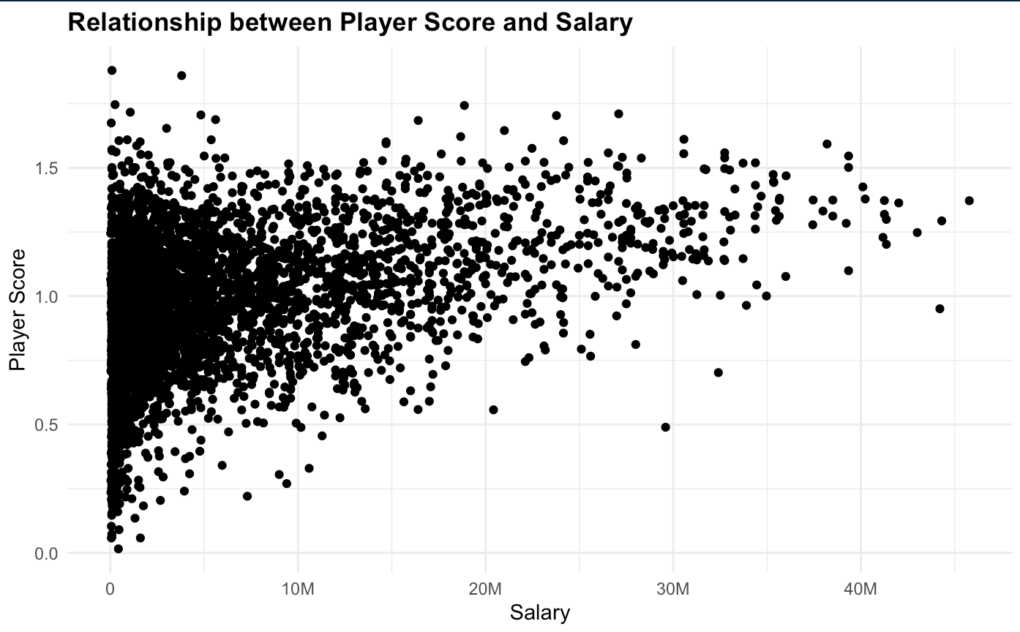

Using a variety of other variables helped us avoid this issue and more reliably generate expected salaries for every player in the league, not only those with substantial minutes played. We used the data from 2012-2022 to train the model and added predictions to the most recent season, which acted as our test set. This ensured we were not training on the data we were interested in evaluating. We began with an intercept only model and defined possible predictor variables to include as all relevant player performance metrics in our data. We used forward selection from the intercept-only model to choose the model with the lowest Akaike Information Criterion (AIC). The objective of this strategy was to add variables one by one to the model and increase the predictive power without adding unnecessary variables. AIC penalizes models which add variables but not much predictive power. The resulting linear model was this:

Salary = - 21732049.64 + 2114955.57 * VORP + 221189.82 * PTS - 579583.28 * STL + 14896909.11 * TREB% + 149730.16 * ORTG + 74182.69 * DRTG + 256377.36 * AST - 9392692.72 * TS% + 8766161.31 * TOV% + 188518.06 * FTM + 269788.67 * FG3M

This model included Value Over Replacement Player which is an attempt at a holistic metric to estimate the points per 100 possessions a player contributes over the average replacement level player in the NBA. It is more robust to small sample sizes than player score because it gives value to players based more on volume than player score. For a full explanation on what goes into the VORP calculation, refer to this [glossary](https://www.basketball-reference.com/about/glossary.html) from Basketball Reference. For predicting salary and not just determining which players are efficient, this is useful.

The model also included offensive measures of success (offensive rating, assists, and turnover percentage), scoring (points, true shooting percentage, free throws made, and 3-pointers made), rebounding (total rebounding percentage), and defense (defensive rating and steals). While these variables cover many aspects of the game, the linear model’s residual failed to meet assumptions for constant variance and normality. Additionally, the slopes for steals and turnover percentage were counterintuitive, since one would think increasing steals and decreasing turnover percentage would lead to an increase in predicted salary on average. Furthermore, predictions in a linear model are not bounded by 0 like salaries are, so the model produced negative predictions for salary. The model was generally inaccurate also, as seen in the graph below. The red line is where predictions would fall if the model was perfect. Predictions appear nearly random.

**Exhibit 11:**

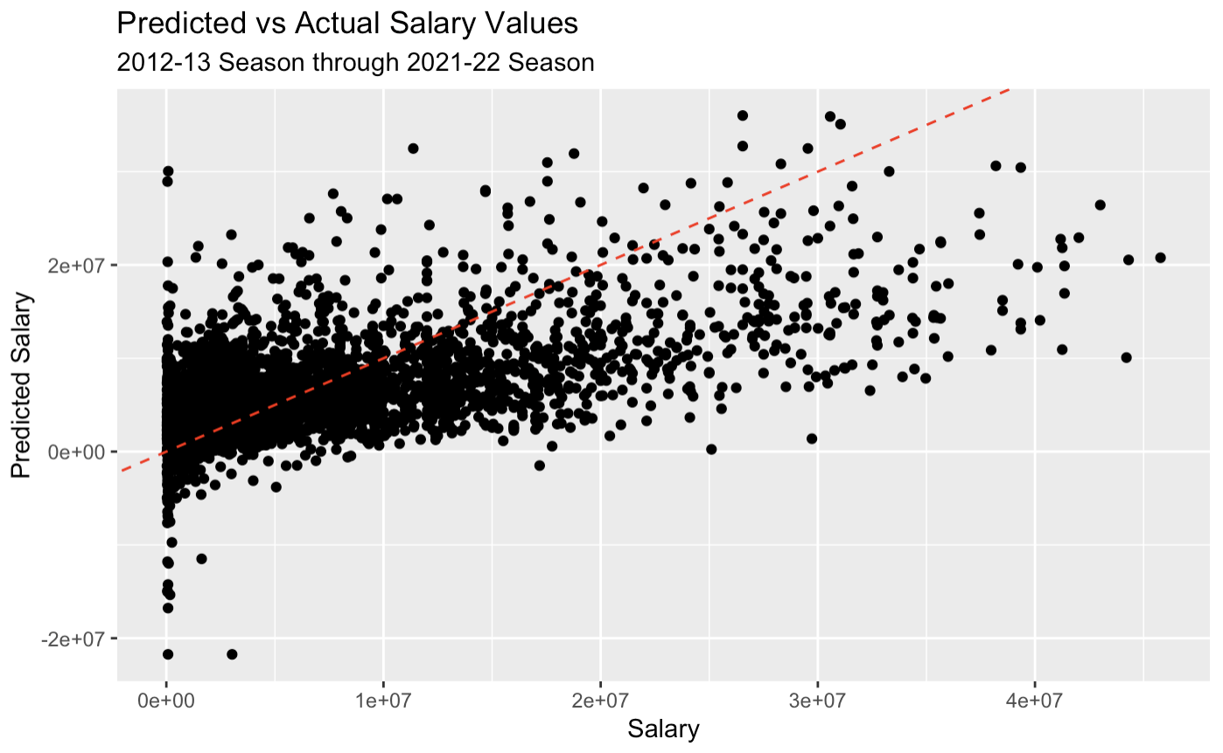

We decided to move to an XGBoost machine learning model to alleviate these predictability issues. We input the same variables into the XGBoost algorithm using 3-fold cross validation and a simple tuning design grid for hyperparameter tuning. This model returned more accurate results, producing fewer negative predictions, reducing the root mean squared error from 5,853,331 to 5,523,550, and increasing the R2 from 0.3977 to 0.4649. The XGBoost model still underpredicted high salary players in general but was a significant improvement from the linear model.

**Exhibit 12:**

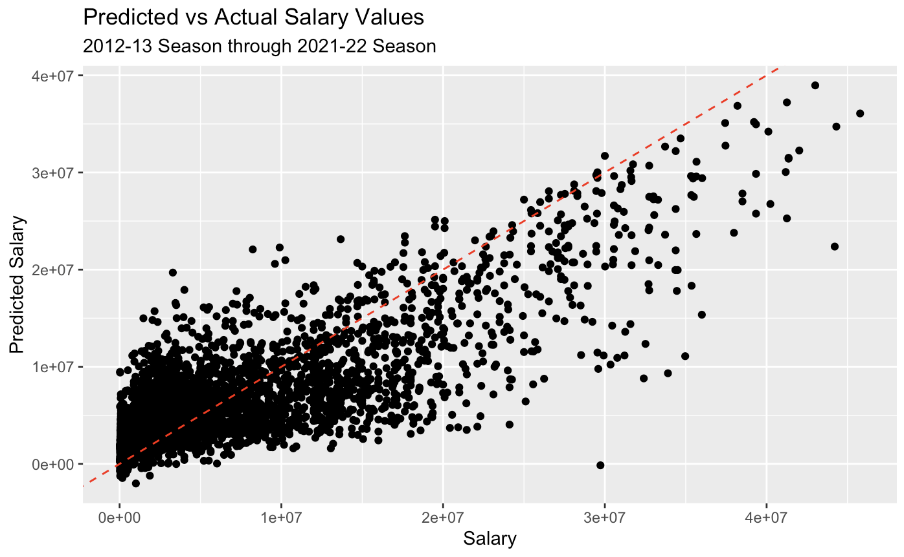

We implemented this model for the 2022-23 season to determine which 76ers are under and over-paid and which free agents are worth targeting in the offseason.

1. **Philadelphia 76ers Team Strengths**

The Philadelphia 76ers had a particularly strong season from a team standpoint. They finished 3rd in the East with a winning percentage of 65.9%, the team’s second highest winning percentage since 2013. They also held the third best record and net rating in the league this season.

With respect to the KPIs we selected, the 76ers were generally near the top of the league as well. The plot below relates winning percentage to EFG%. The 76ers were in the top 20% of all NBA teams in shooting efficiency according to this metric, which is exceptional. They were well clear of the average EFG%, as seen below.

**Exhibit 13:**

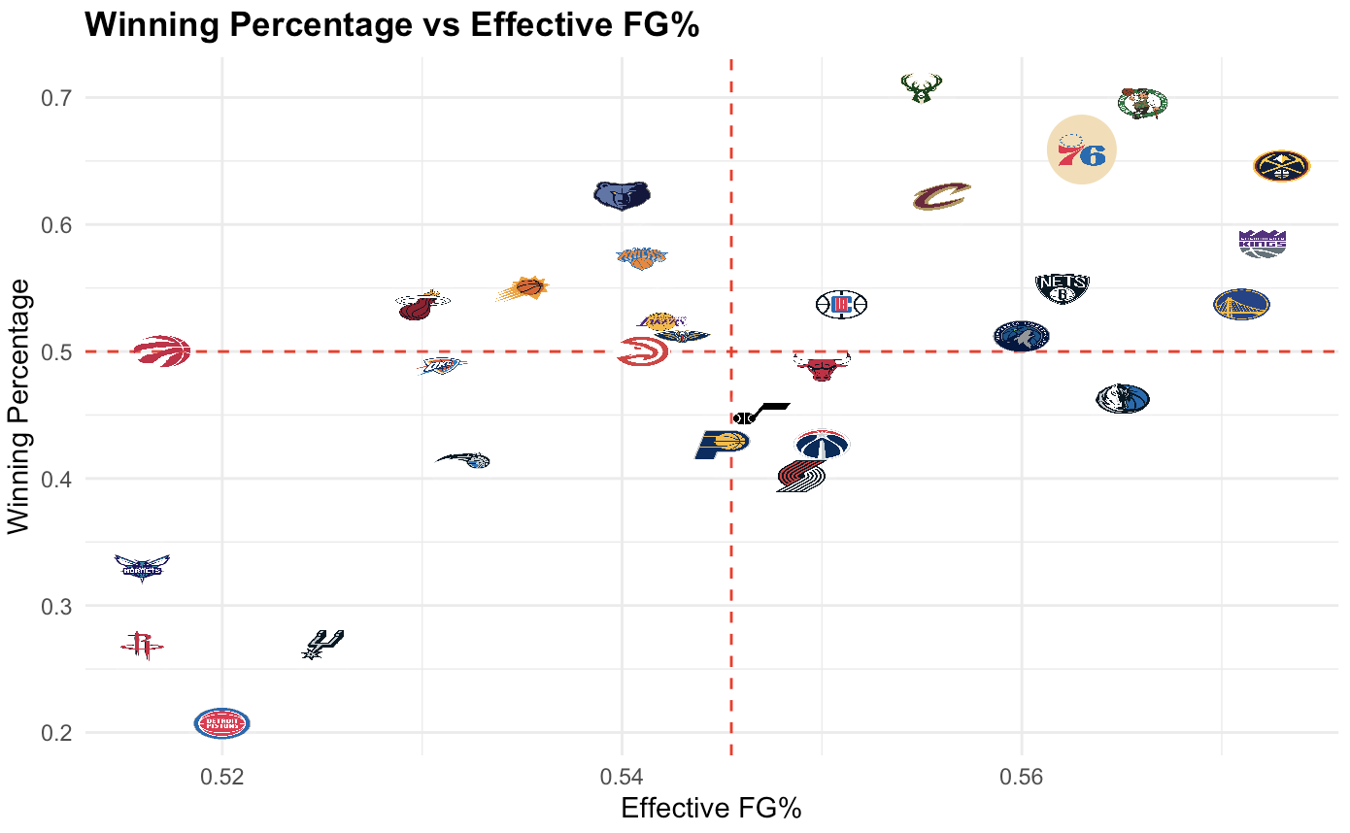

The main reason behind this was the team’s league-topping three-point percentage (38.8%). The team was only slightly above average from inside the arc, however, so this is a possible area for improvement.

**Exhibit 14:**

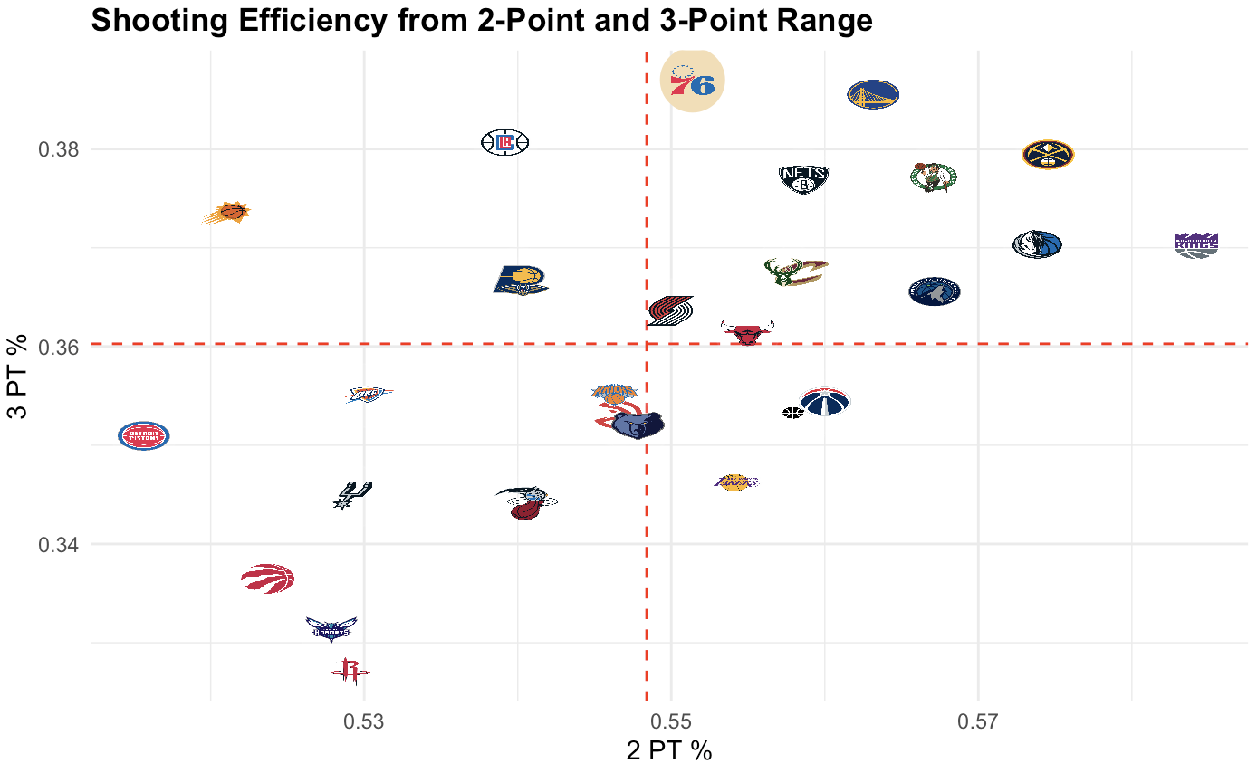

The 76ers were also above average in ball security. Since there is a negative relationship between turnovers and winning, it is optimal to be in the top left quadrant of this graph, which the 76ers occupy. They averaged 13.5 turnovers per 48 minutes, which was slightly below the league average. There is slight room for improvement in this category, especially amongst the team’s highest usage players—Joel Embiid and James Harden—who averaged 4.7 and 4.4 turnovers per 48 minutes. Embiid and Harden were in the 89th and 85th percentile for all players in 2022-23 for turnovers, which is less than ideal.

**Exhibit 15:**

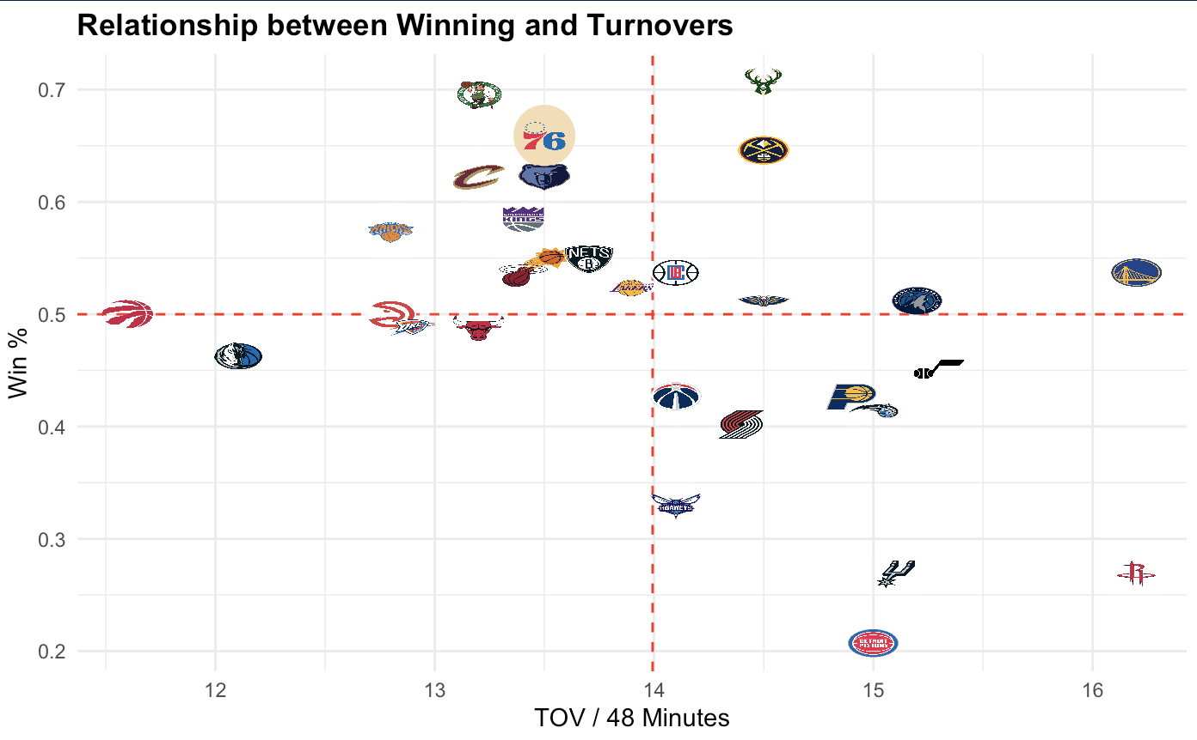

Despite being a strong team overall with a world-class center in Joel Embiid, Philadelphia was a below-average rebounding team according to total rebounding percentage. Breaking this down into its components—defensive and offensive rebounding percentage—we can see that offensive rebounding was a bigger problem than defensive rebounding. Their defensive rebounding percentage was above average, but the 76ers fell short on the offensive boards. A shift in strategy that emphasizes crashing the offensive boards, especially on three-point shots which often lead to long rebounds, could be helpful. Targeting forwards with strong offensive rebounding capabilities in the offseason could be an alternative approach, which we will address in section VIII: Recommended Personnel Changes.

**Exhibit 16:**

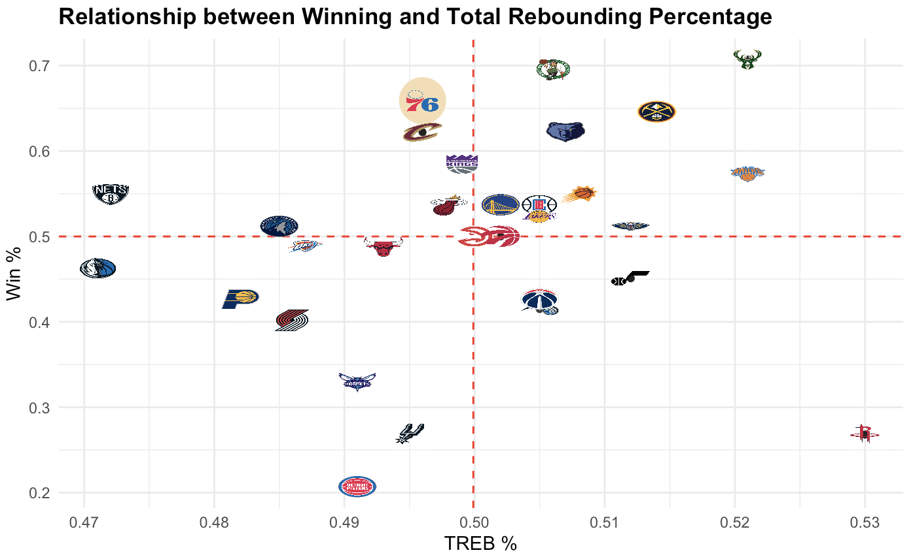

**Exhibit 17:**

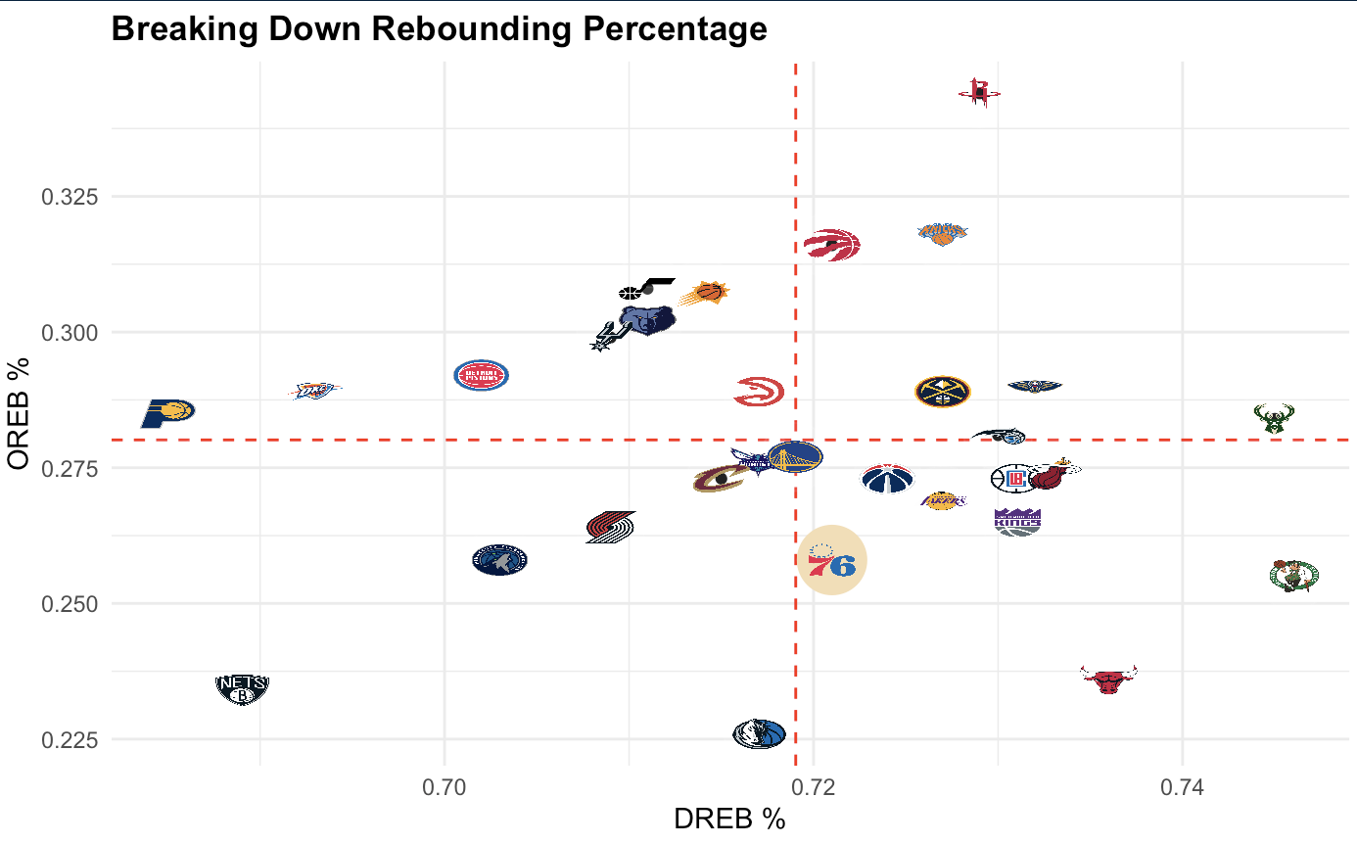

Lastly, we examined Philadelphia’s performance from the charity stripe, which was extraordinary. The team led the league in free throw percentage, converting 83.5% of their attempts. This is especially important for the team to keep up since they had the 8th most free throw attempts per game. This is an area that Philadelphia excels in and could prove useful during the playoffs and in seasons to come.

**Exhibit 18:**

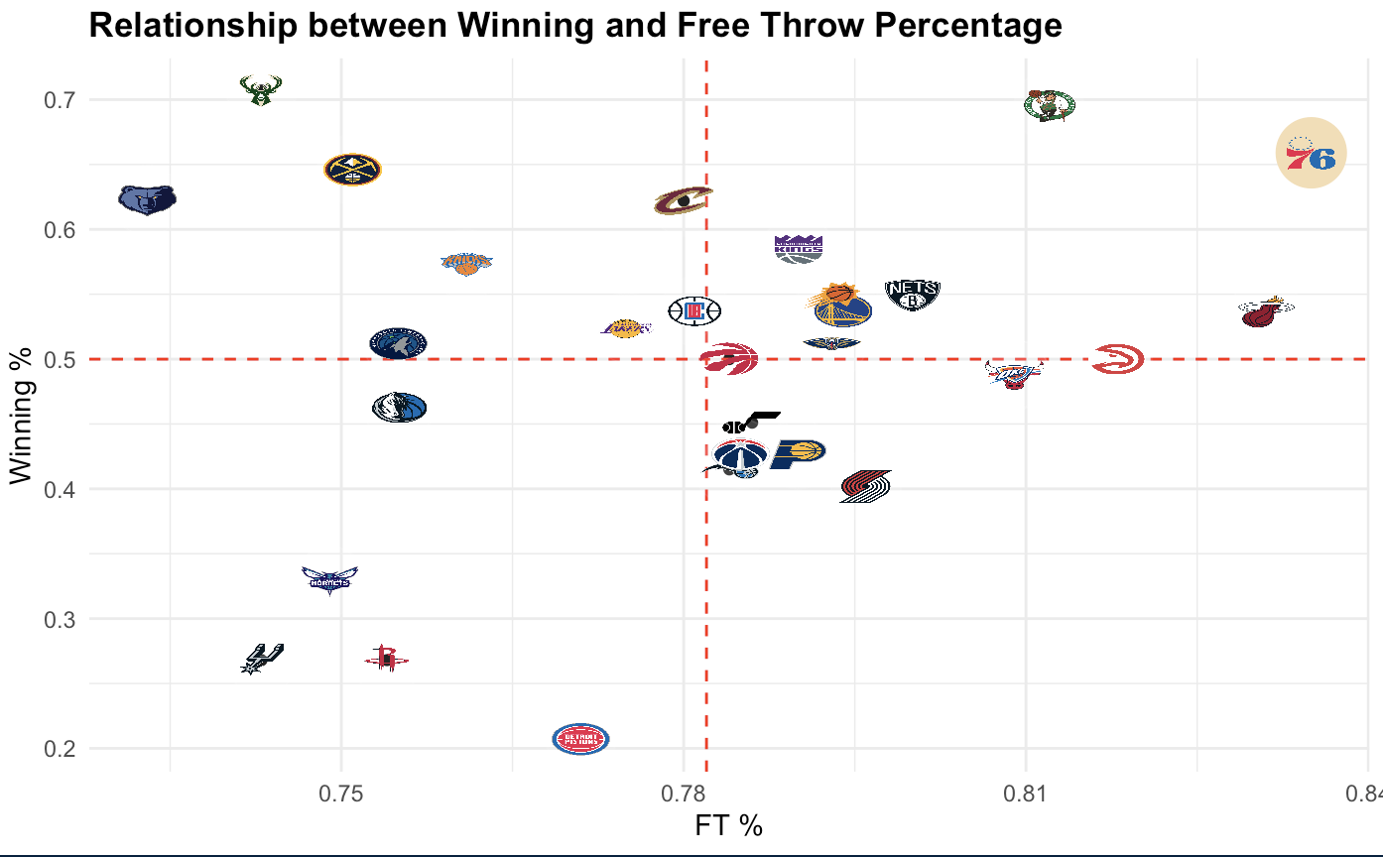

Combining all of these features into our four-factor score, we can once again see the strong positive correlation it has with winning in this past season. Considering the 76ers dominated in most of these categories, it is unsurprising that the team’s FFS was the 6th highest in the league. Their strong position is likely due to their efficient shooting from the field and the free throw line. The four-factor score (along with winning percentage of course) indicates that Philadelphia is amongst the league’s strongest teams, according to Dean Oliver’s four factor philosophy.

**Exhibit 19:**

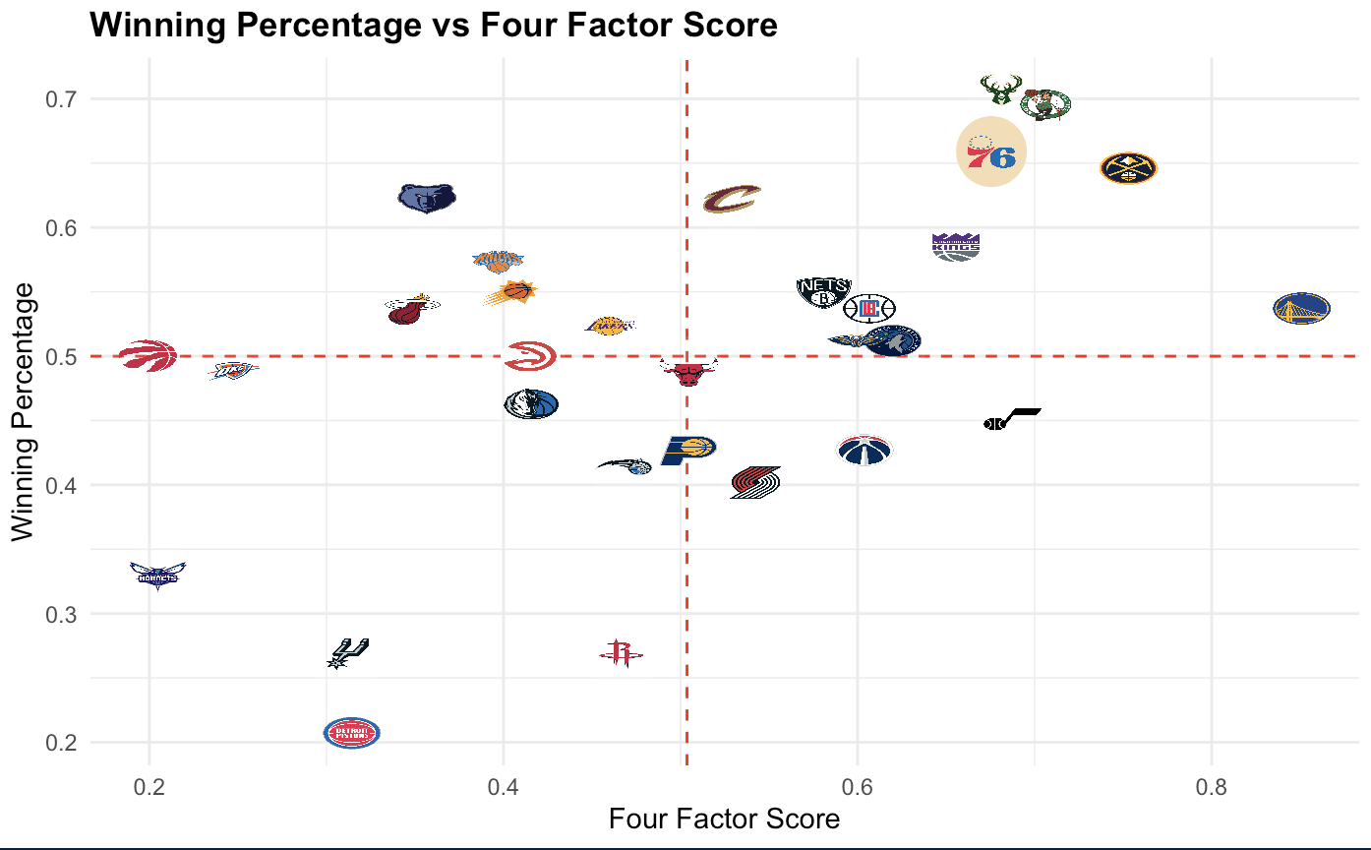

1. **Philadelphia 76ers Personnel Evaluation**

To properly evaluate players on the 76ers’ roster, we looked at player score as well as the percentile of each player in multiple statistical categories in comparison to other players around the league in the same position group. These categories were points, turnovers, offensive rebound percentage, free throws, two-point %, defense within six feet of the basket, three-point field goal percentage, steals, blocks, and offensive and defensive scores. There were some numbers we expected to see, but there were also quite a few surprises as well.

*Points:*

As expected, Joel Embiid leads the team and all centers in the league with his points being in the 99th percentile of all centers. Tyrese Maxey is second on the 76ers followed by James Harden with points in the 86th and 80th percentiles respectively. Their scores are compared to other guards around the league. P.J. Tucker has the lowest point score on the team as well as the entire league when compared to all forwards with his points being in the 2nd percentile. This makes sense as his role on the team is to play defense and make hustle plays with the occasional corner three-point shot.

*Turnovers:*

For turnovers, Embiid and Harden have the worst turnovers scores on the team as they are in the 1st and 14th percentiles, respectively. This is probably due to the high usage rate for both players. However, Maxey’s usage rate is just under Harden’s rate, but Maxey has the second-best turnover score in the 71st percentile for guards on the team behind P.J. Tucker who is in the 83rd percentile for forwards. This means Maxey makes good decisions with the ball in his hands which is impressive since his usage rate is third on the team. On the other hand, P.J. Tucker has the lowest usage rate on the team, so his turnover score is understandable since he doesn’t have the ball in his hands very often.

*Offensive Rebounding %:*

Interestingly, De’Anthony Melton leads the team in offensive rebounding percentage with his score being in the 67th percentile of all guards. He is followed by Tucker with a score in the 61st percentile of all forwards. Surprisingly, Embiid has the second-lowest offensive rebounding percentage behind Georges Niang with OREB% in the 14th and 13th percentiles, respectively. One would expect Embiid, the starting center, to have a higher score so that may be room for improvement for the All-Star.

*Free-throws:*

Embiid leads the team in free throw score in the 86th percentile for all centers, while Melton has the lowest score in the 58th percentile for all guards. All other players on the team are close together in terms of their free throw scores. They all fall somewhere within the range of 67th and 77th percentiles.

*Two-point %:*

The two best players on the team regarding two-point % are Shake Milton and Maxey in the 60th and 59th percentiles, respectively. This makes sense because Maxey takes the ball to the basket often and Milton likes to shoot mid-range jump shots. Tucker and Embiid have the lowest scores on the team. They fall in the 26th and 36th percentiles, respectively. Tucker’s score is understandable as he doesn’t take many two-point shots and he is not very good at shooting. At first, Embiid’s score may seem surprising, but upon further review, it makes sense. He takes the most shots on the team, so the increased volume of shots leads to more missed shots.

*Defensive Within Six Feet of the Basket:*

In terms of defense within six feet of the basket, Niang and Embiid have the two lowest scores: in the 32nd and 33rd percentiles for their positional groups, respectively. Embiid is widely viewed as a very good defender, so this statistic is surprising. This may be due to late switching or simply bad defense. So, this is something the 76ers should keep an eye on. The best score on the team for defense within six feet of the basket belongs to Melton in the 54th percentile for all guards. Melton is seen as a good defender, but having the best defense within six feet of the basket on the team as a guard was not expected.

*Three-point Field Goal %:*

Next is the three-point field goal percentage. Tobias Harris and Embiid have the two highest scores on the team with scores in the 80th and 75th percentiles for their positional groups, respectively. Harris is not seen as the best three-point shooter on the team, so this statistic was a bit surprising. Shake Milton and Melton have the lowest scores on the team: in the 30th and 33rd percentiles for their positional groups, respectively.

*Steals:*

Melton and Jalen McDaniels both have very high steal scores. Melton has the best score in the 89th percentile for all guards on the team and McDaniels has the second best in the 87th percentile for all forwards. Milton has the lowest score in the 14th percentile for all guards on the team with Maxey following who's in the 27th percentile for all guards.

*Blocks:*

Tucker and Niang are tied with the lowest score on the team in blocks with a score in the 22nd percentile for forwards with Maxey very close behind in the 22nd percentile for guards. Tucker is the most surprising of the three as he is seen as a very good defender. Melton and Embiid have the highest block scores on the team with scores in the 74th and 64th percentiles for their positional groups, respectively. Melton so clearly having the highest block score is an interesting statistic to investigate more.

*Offensive Scores:*

The best offensive scores on the team align with expectations. Embiid is in the 81st percentile, Maxey is in the 76th percentile, and Harden is in the 68th percentile for all their positional groups and they lead the team while Tucker has the worst offensive score in the 28th percentile, as expected.

*Defensive Scores:*

On the other end of the floor, Milton, Maxey, and Tucker have the worst defensive scores: in the 26th percentile, 30th percentile, and 31st percentile for their positional groups, respectively. Milton and Maxey are not very surprising, but Tucker having such a low defensive score is very surprising because he is seen as such a strong defensive player. However, he is a hustle player so many of his best attributes are not directly reflected in the statistics. Melton and McDaniels lead the team in defensive scores with scores in the 76th percentile and 66th percentile for their positional groups, respectively.

*Player Scores:*

Player scores are just a combination of their offensive and defensive scores. The top five on the team are Embiid (1.3409395), Melton (1.2213801), Harden (1.1733662), McDaniels (1.1715330), and Harris (1.0863883). Melton and McDaniels are the most surprising of the five, especially as backups. On the other hand, Tucker is substantially lower than all other players with a player score of .5946479. This is due to his very low offensive and defensive scores.

Compared to other teams in the league, Philadelphia produces great value from their roster as whole, ranking third in the league with an average player score of 1.05. However, when restricting the sample to players who played over the average number of minutes (1100), the Sixers average player score rank drops to 21st. This suggests that the team could be deriving more value from its typical rotation. This is especially true on the defensive end, where the team ranked 24th in defensive score on the season.

1. **Philadelphia 76ers Salary Value Creation**

To examine if the 76ers are creating value with respect to salaries, we broke down the analysis by the positional groups of guard, forward, and center. Then focusing primarily on notable players playing over 1100 minutes over the course of the 2022 regular season, we identified players who created value with respect to their salary and those who did not.

**Exhibit 20:**

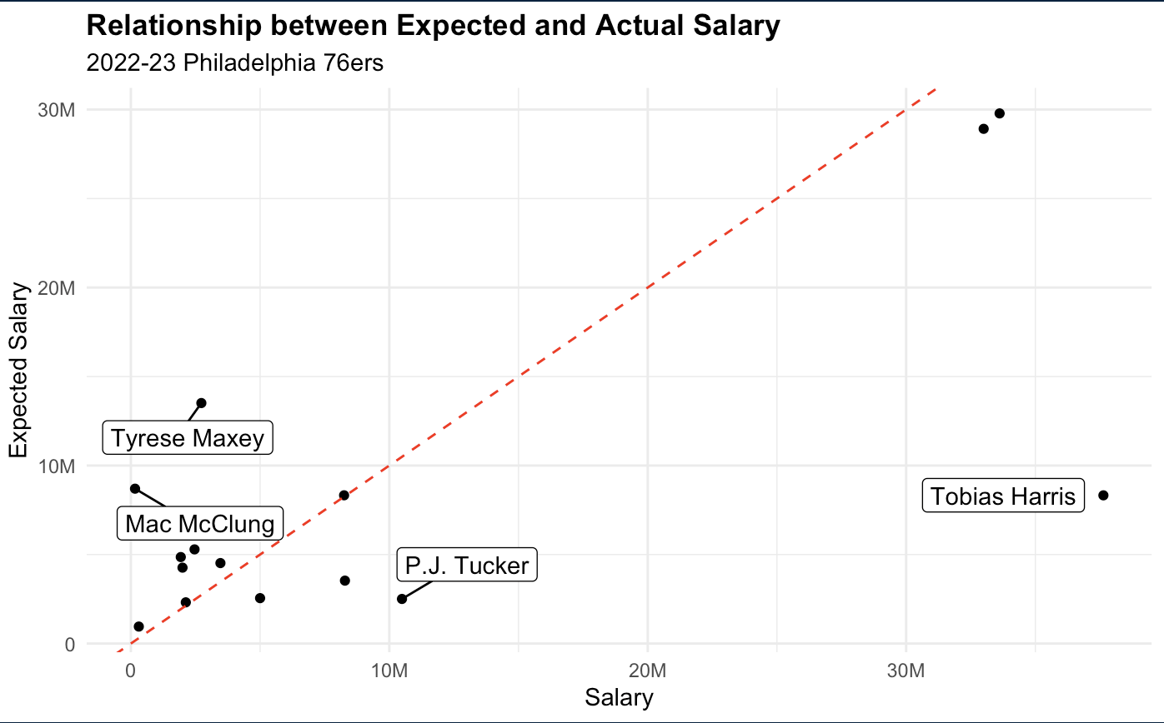

*Guards:*

Examining first whether the 76ers are creating value within the guard position, James Harden stands out as the only notable guard where the 76ers are not creating value, as evidenced by his salary of $33,000,000 being greater than his expected salary. However, this contract is not very burdensome for the 76ers because Harden falls relatively close to the reference line, which marks a 1:1 relationship between expected and actual salary. Additionally, the model tends to underpredict large salaries, so most high-paid players are “expected” to make slightly less than they do. We will take this into account when evaluating highly paid players like Harris, Embiid, and Harden.

While James Harden slightly underperforms his salary, the 76ers have created value with respect to salaries for the other notable guards on the roster, including De’Anthony Melton and Shake Milton, with salaries of $8,250,000 and $1,997,718 respectively being lower than the expected salaries for both guards. De’Anthony Melton is particularly notable because he stood out as an incredibly efficient addition to the team according to player score and defensive score which was the highest on the 76ers. Additionally, the 76ers are also creating value with less notable guards who are not core rotational players, such as Mac McClung and Jaden Springer, who receive limited playing time. However, due to their small salaries, their expected salaries suggest they still provide more value than their actual salaries.

*Forwards:*

Concerning forwards, the 76ers again have forwards who are both exceeding expectations and those who are not. The most notable forward who is not creating value is Tobias Harris whose actual salary of $37,633,050 was the highest on the team and was significantly higher than his expected salary. With Tobias Harris, his ORB% falls into the 29th percentile when compared to other forwards and his player score is the 5th highest on the 76ers signaling that his contract is a major issue for the 76ers. Another notable forward who is not creating value for the 76ers is P.J. Tucker, whose salary of 10,490,000 is lower than his expected salary however, with P.J. Tucker, his strengths of shooting and rebounding shine through. In addition, as was the case with guards, other notable forwards on relatively small contracts such as Jalen McDaniels and Georges Niang are creating value for the 76ers with their expected salaries being greater than their respective salaries of 1,930,681 and 3,465,000. Looking beyond notable players in the rotation, the 76ers were also able to create value through the contracts of Paul Reed and Montrezl Harrell.

*Centers:*

Lastly, looking at centers surprisingly, the 76ers were unable to create any value through their contracts for their centers. Examining Joel Embiid first, his expected salary falls below of that of his actual salary of $33,616,770. However, as was the case with James Harden, in Joel Embiid’s case, his contract is very close to the reference line and the model underpredicts large salaries, so this is not a concern. With their backup center, Dewayne Dedmon, the 76ers again were unable to create value through his salary with his expected salary falling below his actual salary of $8,283,688.

1. **Recommended Personnel & Team Changes**

*Team Recommendations:*

Starting with recommendations from a team perspective, the first recommendation we have for the 76ers is to improve upon their offensive rebounding. As mentioned above, despite having MVP candidate center Joel Embiid, the 76ers struggle to pull down a high OREB%, falling well below the league average. One potential explanation for the relatively low OREB% compared to the rest of the league is the 76ers usage of their superstar center Joel Embiid where on the offensive end, he is taking a significant amount of three point and mid-range shots affecting his rebounding positioning and causing his OREB% to fall into the 14th percentile when compared to other centers. This issue is exacerbated by the fact Dewayne Dedmon struggles as a rebounder when compared to other centers falling into the 30th percentile for ORB%. As a result, there is a potential need and opportunity to surround Joel Embiid, a core component of the 76ers roster, and future plans with forwards who are strong with respect to OREB%.

The second recommendation, from a team perspective, that the 76ers can address with future personnel changes is improving on their 2pt%. While the 76ers led the league in 3pt%, shooting 38.8% in the 2022 regular reason, their 2p% did not stand out to the same extent, only falling slightly above average and trailing playoff teams such as the Milwaukee Bucks and Boston Celtics. With this in mind, the 76ers going forward can look to shape their team with players able to more efficiently take advantage of the spacing provided by the league-leading 3p%. Additionally, the 76ers’ star, Joel Embiid, does not excel in 2pt% as he is in the 36th percentile compared to other centers who take easier shots. As a result, it is important to surround Embiid with players who can score efficiently from inside the arc with high 2pt%’s.

*76ers Personnel Recommendations:*

In order to open up cap space flexibility to address the highlighted team recommendations and to ensure the 76ers are not losing significant amounts of value by paying players significantly more than their expected salary, the 76ers can first look within their own teams' personnel. The first recommendation concerning the 76ers personnel comes from the glaringly obvious overpay of Tobias Harris compared to his expected salary. As is highlighted in the 76ers Salary Value Creation section, Tobias Harris was the highest-paid player for the 76ers during the 2022 regular season, while his expected salary suggests his salary should be more along the lines of the 4th or 5th highest paid. As a result, we recommend the 76ers either trade him this offseason or attempt to resign him at a more reasonable contract that better aligns with his expected salary. If he is uninterested, let him leave in free agency. As an expiring contract next year, Tobias Harris could garner trade interest from teams rebuilding teams looking to unload salary through expiring contracts, which could allow the 76ers to either unload his expensive contract or trade for players whose salaries better align with their expected salaries and address some of the 76ers areas where they struggle. With the second option, the 76ers would either be getting Tobias Harris on a cheaper deal that better aligns with his play, or they would be clearing cap space that can be spent better elsewhere on forwards who address the issue of OREB% as this was a weakness of Tobias Harris.

Our next personnel recommendation for the 76ers within their team is to extend Tyrese Maxey when he becomes a restricted-free agent in 2024. As it currently stands, with his salary of $2,726,880, Tyrese Maxey is outperforming his current rookie contract, with his expected salary being much higher than his actual salary. Tyrese Maxey's expected salary suggests that his salary should be the third highest on the team. As a result, when contract negotiations come up in the future, the 76ers should pay him in accordance with that to ensure they are not letting a valuable piece of their team leave. With an offensive score in the 76th percentile of guards in the league and second on the 76ers trailing only Joel Embiid, Tyrese Maxey is a critical component of the 76ers. Letting him leave would only exacerbate issues in areas where they should look to improve, such as 2pt% as he is in the 59th percentile for 2pt% out of all guards.

*Personnel Acquisition Recommendations:*

Due to our personnel recommendations for the 76ers within their own team, suggesting that they extend Tyrese Maxey and potentially move on from Tobias Harris. Our personnel recommendations for the 76ers to make pertaining to acquisitions will be centered around the forward position, where they can trade for or acquire players that address some of our team recommendations.

Our first personnel recommendation for the 76ers is to target a stretch four with a good OREB%, decent player score, and who is undervalued according to our salary model. Making an addition fitting this criterion would allow the 76ers to address its relative struggles with OREB% while simultaneously ensuring they create value through their salaries. One soon-to-be free agent stretch four that fits this description is Jarred Vanderbilt of the Los Angeles Lakers, who is slotted to reach free agency in 2024, lining up with when Tobias Harris will be a free agent and cap space will be more abundant. With a TREB% in the 92nd percentile, Vanderbilt is an elite rebounding forward which, combined with his decent player score and undervalued salary, would provide immediate relief for the 76ers. On top of this, Vanderbilt also is in the 70th percentile of 2pt% for forwards which helps address the second issue highlighted in our team recommendations. Additionally, the 76ers could look to acquire Bobby Portis from the Milwaukee Bucks through a trade revolving around Tobias Harris. Bobby Portis has an OREB% in the 86th percentile of forwards, a 2pt in the 52nd percentile of forwards, and a solid player score while also being undervalued with respect to salary. As a result, both Jarred Vanderbilt and Portis address the 76ers' offensive rebounding issues with their good offensive rebounding percentages and 2-point percentages while also serving as good value additions according to our expected salary model.

Our second personnel recommendation we have for the 76ers would be to target a small forward with the same qualities listed above. These acquisitions will again allow the 76ers to address their struggles with OREB % while creating value through salaries. The first player we have identified at the small forward position who fits this criterion is Torrey Craig. Torrey is an unrestricted free agent in this upcoming 2023 offseason and would be a great value addition and will help to offset the 76ers issues with OREB% as he is in the 81st percentile for forwards. Additionally, the 76ers could look to add Jae Crowder as he is an unrestricted free agent in the 2023 offseason as well to address this issue with his OREB% falling into the 49th percentile which is higher than many of the 76ers current forwards at a valuable salary. Jae Crowder’s 2pt% is also in the 49th percentile for forwards which would help boost the 76ers 2pt%. Both of these small forwards have decent player scores and are undervalued in terms of their salary also fitting within the criterion.

1. **Conclusion**

In conclusion, with our recommendations spanning from concerning the team, 76ers personnel, and potential personnel acquisitions, we have addressed several ways the 76ers can improve upon a successful 2022 regular season. To summarize with our team recommendations, the 76ers should work to address what we identified as a relatively low OREB% and should work to improve upon their teams' 2p%, which we also concluded is not adequately taking advantage of their league-leading 3pt%. Next, examining the 76ers current personnel, we believe that the 76ers should either trade Tobias Harris or attempt to re-sign him for a cheaper deal more in line with his expected salary and, if he is unwilling to do so, should let him leave. On the other hand, we believe extending Tyrese Maxey is in the 76ers' best interest when examining his expected salary and his importance to the 76ers, which is signified by his strong offensive score. Lastly, we proposed various personnel acquisitions that would address a potential positional group of weakness for the 76ers, which would be forwards if Tobias Harris is moved. Within this, we recommended that the 76ers look to add stretch fours or small forwards that have a good OREB %, a decent player score, and are being undervalued according to our salary model. With that, we identified Jarred Vanderbilt, Bobby Portis, Torrey Craig, and Jae Crowder as great fits who the 76ers should look into acquiring. All in all, these recommendations offer solutions to the conclusions we made that the 76ers need to improve OREB% and 2pt% while addressing the forward position, where we concluded that the 76ers were not currently creating value.